Lab-8 SSL/TSL Cer ficate
Task-1: . SSL/TLS Cer ficate Valida on Tool: OpenSSL, Web Browsers Prac cal:
Check the SSL/TLS cer ficate of a website.
Inspect the expira on date, issuer, and encryp on details. Validate a cer ficate chain.
- Website Tested: https://example.com/
- Issuer: DigiCert Inc
- Validity: From 15 Jan 2025 00:00:00 GMT
To 15 Jan 2026 23:59:59 GMT
- Status: Valid
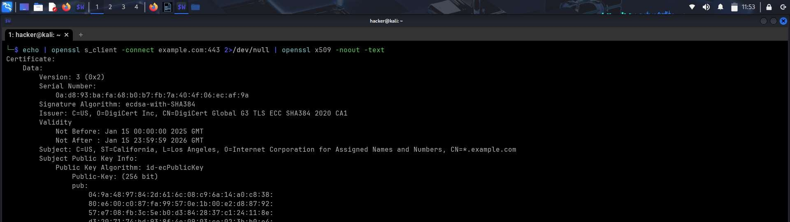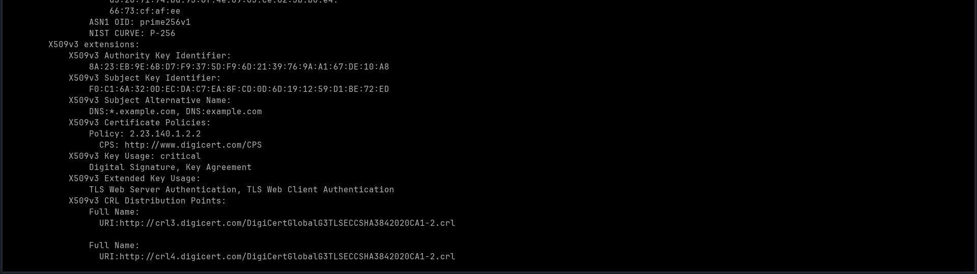
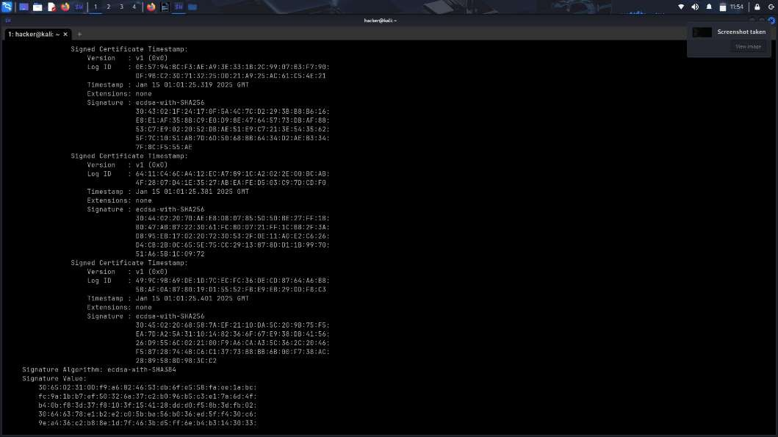
Task-2: Web-Based SSL/TLS Cer ficate Tes ng:
Tool: SSL Labs
(www.ssllabs.com/ssltest/)
Prac cal: Analyze the SSL/TLS security of a website.
Iden fy vulnerabili es like weak ciphers or expired cer ficates.
- For the scanning in ssl labs website, i have used this url: h ps://classroom.google.com/ of classroom home page for scanning purpose.
- As per the lab scan result, the Grade for this website was found as “B” from 10 different servers which have scanned for this website.
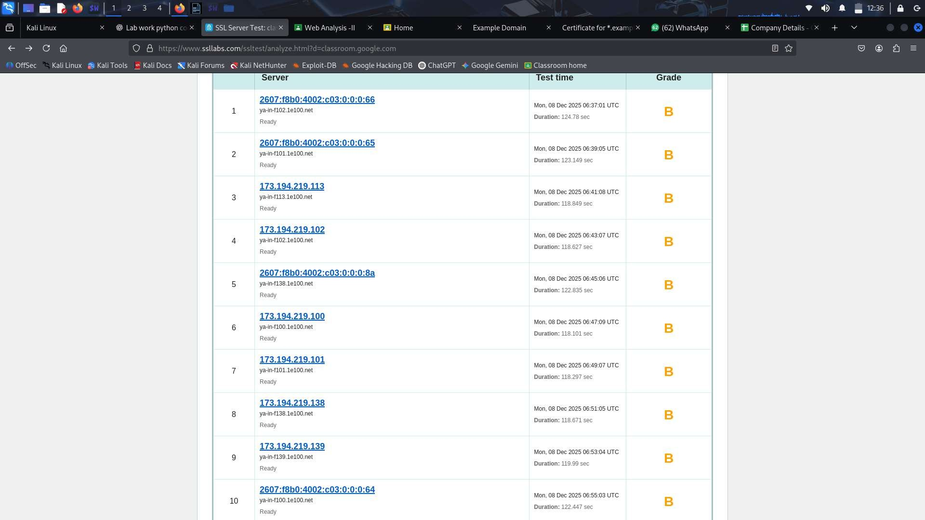
- The results showcase all details about the summary as:
    - This server supports TLS 1.0 and TLS 1.1. Grade capped to B.
    - This server supports TLS 1.3.DNS Cer fica on Authority Authoriza on (CAA) Policy found for this domain.
    - The cer ficate is valid from 27 Oct 2025 08:35:33 UTC to 19 Jan 2026 08:35:32 UTC.
    - Key - EC 256 bits, Issuer – WE2, Signature algorithmSHA256 with ECDSA, Cer ficate Transparency – Yes.
    - Trusted – Yes, DNS CAA- Yes
- I have also a ached a so copy of the cer ficate issued from the ssl labs.

Task 3: Digital Cer ficate Crea on & Management Tool: OpenSSL
Prac cal: Generate a self-signed cer ficate using OpenSSL. Create a Cer ficate Signing Request (CSR). Sign a cer ficate using your own Cer ficate Authority (CA). Verify and inspect the cer ficate details.
Export and import cer ficates in different formats (PEM, DER, PFX).
- For this lab, first of all i have created a ca.key private key.
- Then i have created a Self signed CA cer ficate, with the name as ca.crt, all the fields filled up in this manner
  - Country Name (2 le er code) [AU]:IN
  - State or Province Name (full name) [Some-State]:Gujarat
  - Locality Name []:Bharuch
  - Organiza on Name (eg, company) [Internet Widgits Pty
Ltd]:My Test CA
  - Organiza onal Unit Name (eg, sec on) []:Test CA
  - Common Name []:test server
  - Email Address []:meet.2k21@gmail.com
- Here the ca.crt is the root CA cer ficate and is self-signed.
- Using openssl verify, the server cer ficate was successfully validated using the CA cer ficate, confirming a correct cer ficate chain in our mini PKI.
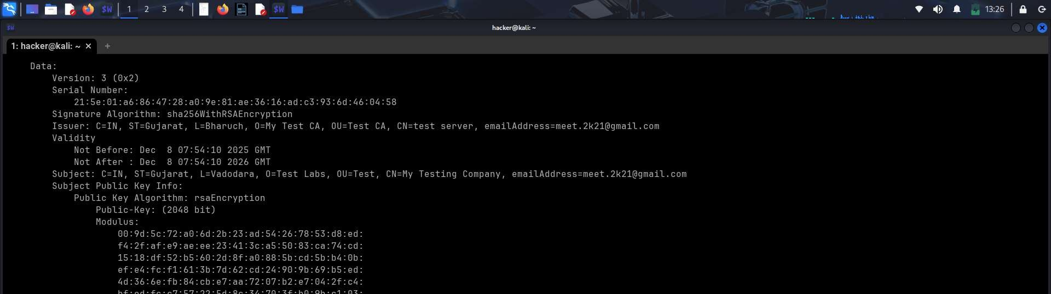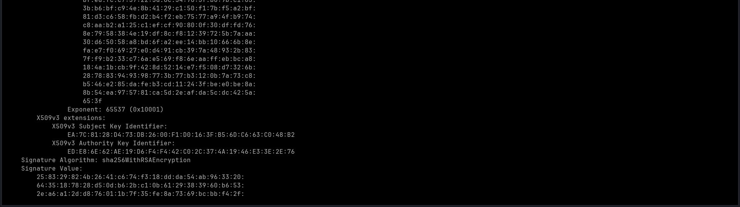

- This image is the output for the verifica on of the cer ficate which was run in terminal by using ssl verfica on is successfull against CA.

